**GROUP ASSIGNMENT**

**TECHNOLOGY PARK MALAYSIA**

**AAPP010-4-2-PWP**

**PROGRAMMING WITH PYTHON**

**UCDF2106BIT / UCDF2106ICT(SE) / UCDF2106ICT(DI) / UCDF2106ICT(ITR) / UCDF2106ICT**

**HAND OUT DATE: 4TH July 2022**

**HAND IN DATE: 12th Sept 2022**

**WEIGHTAGE: 100%**

**INSTRUCTIONS TO CANDIDATES:**

1. Submit your assignment online in MS Teams unless advised otherwise
2. Late submission will be awarded zero (0) unless Extenuating Circumstances (EC) are upheld
3. Cases of plagiarism will be penalized
4. You must obtain at least 50% in each component to pass this module

**STUDENT NAME :** 1) YAU KAI JOON 2) LIM YEE ERN

**TP NUMBER :** 1) TP064474 2) TP065084

**LECTURER NAME :**  Mr. Amardeep

Table of Contents

**1.** **Introduction and Assumptions** 4

**2.** **Design of the program** 5

**2.1 Pseudocode** 5

2.1.1 Pseudocode of Main_Menu 5

2.1.2 Pseudocode of Login And Registration Form 5

2.1.3 Pseudocode of Login 6

2.1.4 Pseudocode of Guest Menu 6

2.1.5 Pseudocode of Tenant List Display 7

2.1.6 Pseudocode of Apartment list Display 7

2.1.7 Pseudocode of Past Tenant Display 8

2.1.8 Pseudocode of Modify Menu 8

2.1.9 Pseudocode of Modify Tenant 9

2.1.10 Pseudocode of Modify Apartment 11

11

2.1.11 Pseudocode of Modify Past Tenant 12

2.1.12 Pseudocode of Register 13

2.1.13 Pseudocode of Payment Form & Payment_Detail 14

2.1.14 Pseudocode of Maybank 15

2.1.15 Pseudocode of Public Bank 15

2.1.16 Pseudocode of CIMB Bank 16

**2.2 Flowcharts** 17

2.2.1 Flowchart of Main_Menu 17

2.2.2 Flowchart of Login and Registration Form 18

2.2.4 Flowchart of Guest Menu 20

2.2.5 Flowchart of Tenant list 21

2.2.6 Flowchart of Apartment list 22

2.2.7 Flowchart of Past Tenant list 23

2.2.8 Flowchart of Modify Menu 24

2.2.9 Flowchart for Modify Tenant 25

**3.** **Programming Concepts with source code for Explanation** 27

**4.** **Screenshots of sample input/output and explanation** 31

4.1 Menu 31

4.2 Register 31

31

4.3 Log in 32

4.4 Guest View 32

4.5 Modify 34

4.6 Payment 36

36

**5.** **Conclusion** 39

**6.** **Appendix** 40

# **Introduction and Assumptions**

Python is a computer programming language that can be used to create software and websites, automate processes, and analyze the data. Python is a general-purpose language, which means it may be used to make many various types of applications and isn't designed for any issues. People frequently use the programming language Python for certain purpose. Therefore, David and John have many years of experience in the apartment rental business. They intend to maintain logs of their rental apartments on the computer recently with being hands-on required to create their first Python application. In order to meet John and David's needs, a Python application framework needs to be developed. David made the decision to complete the online Python course and created the code for their application, which assist John keeps adding more requirements.

Creating a programming language has some steps. First, before running the source code, designing pseudocode is a necessary step. It is because Pseudocode is a simple way to explain what a collection of computer instructions in a form is, well making it more simple for non-programmers to understand. Second create the flowchart by using the pseudocode. Using flowcharts to describe the logical concepts of pseudocode is a good idea so that people will be more better understanding by looking the charts.

In addition, making a lot of logical assumptions is necessary when developing the Python code. There is an uncountable code while developing application. Each assumption functions in a different way. For example, there are assumptions regarding create records, adding details, delete records, find special records, displaying details(Guest View), and many more in this assignment. Especially when people perform in adding details, the file's input or output operations such as **open, close, read, write,** and **append** will be carried out. Besides, when people displaying records, the text file will be only **opened, read,** and **closed**. Additionally, when users choose the exit assumptions, the source code that will soon run will be broken means the program have to be run it all over again. There are also some details which need to be linked or appended it to File.txt such as register and modify tenants. Moreover, if the test able to run successfully, it will print out with successfully entering the stuffs or else it will be showing out “Error, Please Try It Again”. But if the whole programming test error to run, probably means there must be some error on the coding line. That’s basically the most challenging part when running a program.

# **Design of the program**

## **2.1 Pseudocode**

### 2.1.1 Pseudocode of Main_Menu

### 2.1.2 Pseudocode of Login And Registration Form

### Graphical user interface, text, application Description automatically generated2.1.3 Pseudocode of Login

### Graphical user interface, text, email Description automatically generated2.1.4 Pseudocode of Guest Menu

### Text Description automatically generated2.1.5 Pseudocode of Tenant List Display

### Text Description automatically generated2.1.6 Pseudocode of Apartment list Display

### Graphical user interface, text Description automatically generated2.1.7 Pseudocode of Past Tenant Display

### 2.1.8 Pseudocode of Modify Menu

### Text Description automatically generated with low confidence2.1.9 Pseudocode of Modify Tenant

Proceed on Modify Tenant…

### 2.1.10 Pseudocode of Modify Apartment

### 2.1.11 Pseudocode of Modify Past Tenant

### 2.1.12 Pseudocode of Register

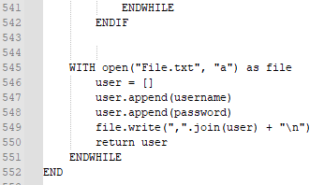

### 2.1.13 Pseudocode of Payment Form & Payment_Detail

### 2.1.14 Pseudocode of Maybank

### 2.1.15 Pseudocode of Public Bank

### 2.1.16 Pseudocode of CIMB Bank

## **2.2 Flowcharts**

### 2.2.1 Flowchart of Main_Menu

2.2.2 Flowchart of Login and Registration Form 2.2.3 Flowchart of Login

### 2.2.4 Flowchart of Guest Menu

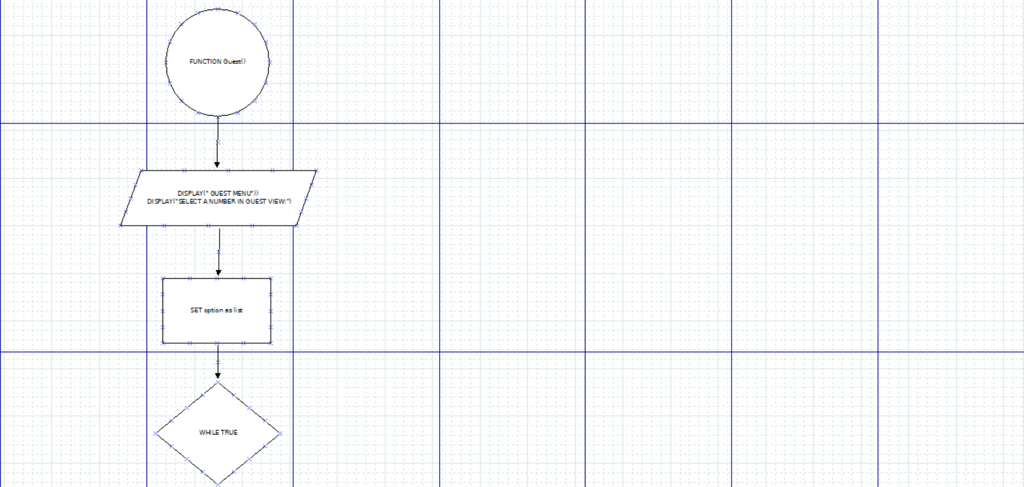

### 2.2.5 Flowchart of Tenant list

### 2.2.6 Flowchart of Apartment list

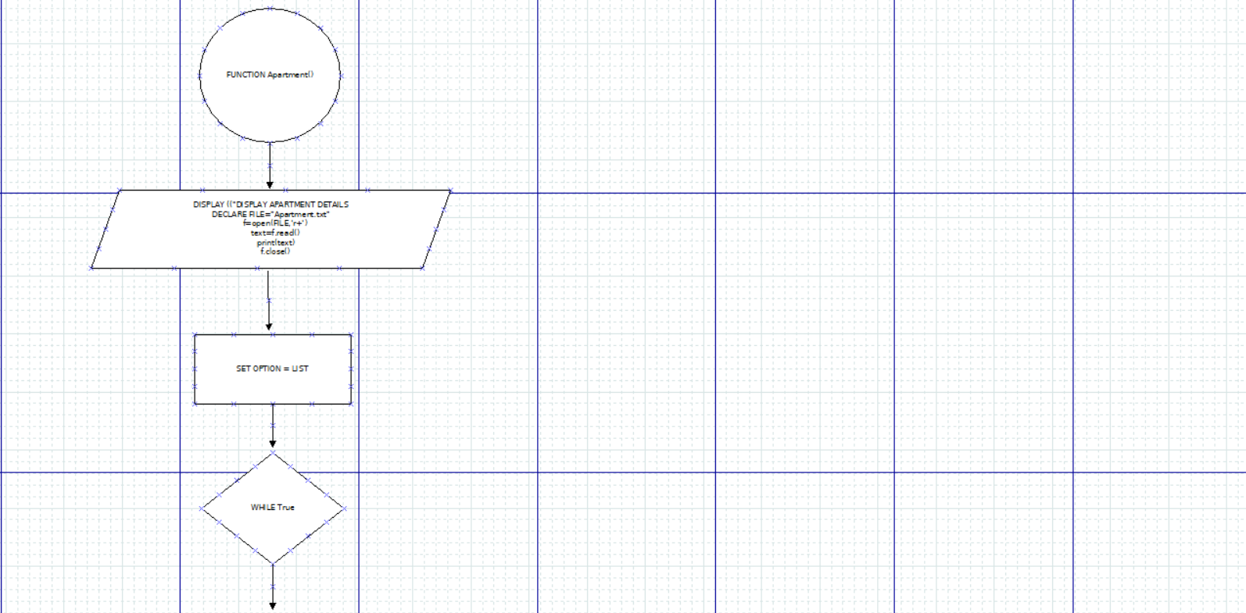

### 2.2.7 Flowchart of Past Tenant list

### 2.2.8 Flowchart of Modify Menu

### 2.2.9 Flowchart for Modify Tenant

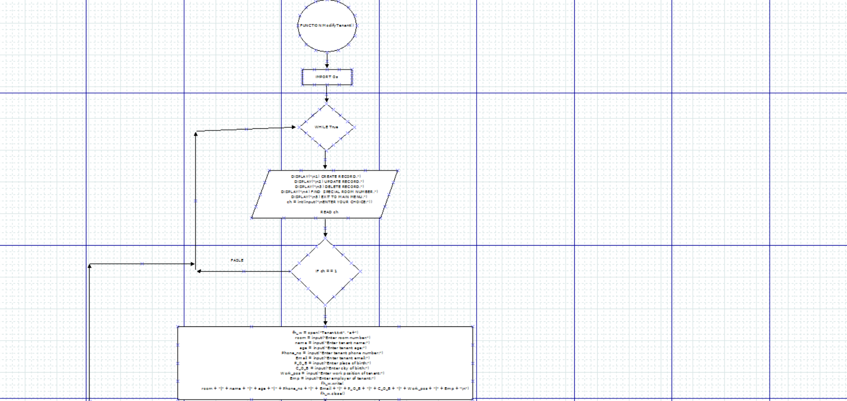

# **Programming Concepts with source code for Explanation**

* Function:
* Function can be shown in python as “def”. It is a chain of codes that runs when it is called.



* The function can be called by using function name
* A return statement is used to exit the function another place appointed



* Variables
* Variables are container for storing data values
* A variable is created the second you assigned value to it



* List
* Lists are used to store multiple items within a single variable



* Append is used to add variable into the list



* Len() command is used to get the length of string/list etc.



* Files
* Files has multiple functions for creating, reading, updating and deleting files
* Files are usually opened by open() function
* There are different modes to open file with different type of additional commands
* ‘r’ (read) is for reading file, ‘w’ (write) for writing content in the file , ‘a’(append) is to open a file for appending, creates the file if not existed







* At the end, we need to close the file or exit the file to make sure the changes we do exist.

* User input
* Input() function is used for users to input data. Data can be different type such as integers, float or strings.
* Integers(int) are numeric data types that stores integers only.
* Users may enter any data with the input function input() only as there’s no specific data type mentioned



* Print function
* The print() function prints specified message to the screen, or other standard output devices.



* Condition/ If statements
* If statement determines if an expression is true or false. When the condition is true, the true block command will execute while the condition is elif or else condition, the command in another block will then execute.

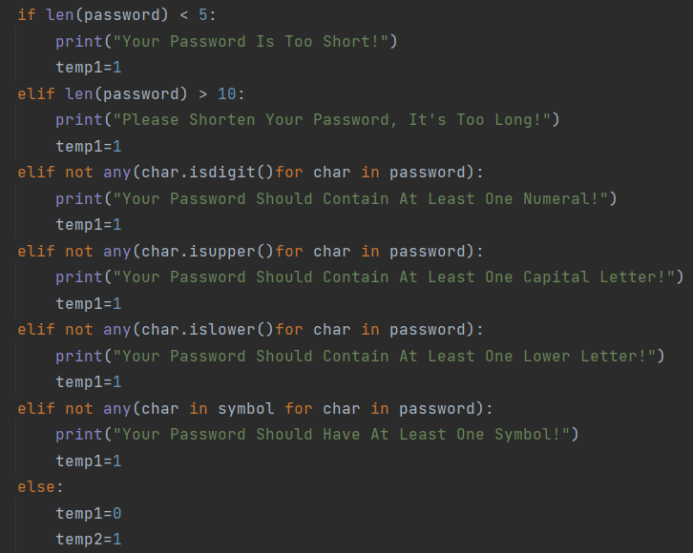

* Loops
* With loops, we can execute a set of statements as long as the condition is true
* The while loop requires variables to be ready.
* Text

  Description automatically generatedFor loop is used for run a set of statement or looping through an object such as string or list.
* Break statement is to terminate the loop under a true condition
* Datetime
* Date in python doesn’t count as a data type of its own, but python can import a module named datetime to work with the dates as date objects.

* Os module
* The Os module in python provides functions for creating and removing a directory, fetching contents, changing and identifying current directory



# **Screenshots of sample input/output and explanation**

### Graphical user interface, text Description automatically generated4.1 Menu

This is basically the **Menu** which allows David or John to proceed their options. There are total of 2 options in Menu

If proceed **(1)** to **Login & Registration** , you can select either ‘Login’ or ‘Register’.

### 4.2 Register

When user go for option 2 which is **Register part**, it requires to register an account by entering a new username and password.

If the password doesn’t meet the requirement, it will be showing out until user hit the correct requirement. Same goes to ‘Please re-confirm your password:’.

After successfully registered an account, the new username and password will be linked it into a File.txt.

### 4.3 Log in

Once you have registered an account, it will straight jump into the **Log in part**. Well, incorrect username or password will show ‘Invalid’ until with the right username and password to proceed next.

### Text Description automatically generated4.4 Guest View

Once login success, select number **(1)** **Guest View** to display Tenant Details, Apartment Details, and Past Tenant Details.

Display Tenant Details. Select **(1)** exit back to the Main Page ; Select **(2)** exit to the Guest Menu.

Display Apartment Details. Select **(1)** exit back to the Main Page ; Select **(2)** exit to the Guest Menu.

Display Past Tenant Details. Select **(1)** exit back to the Main Page ; Select **(2)** exit to the Guest Menu.

### 4.5 Modify

Once login success, select number **(2)** **Modify** to modify Tenant Details, Apartment Details, and Past Tenant Details.

**(MODIFY TENANT DETAILS AS ONE EXAMPLE)**

First **Create Record**, fill up the details for tenant. Once tenant details added, it will be linked to File.txt.

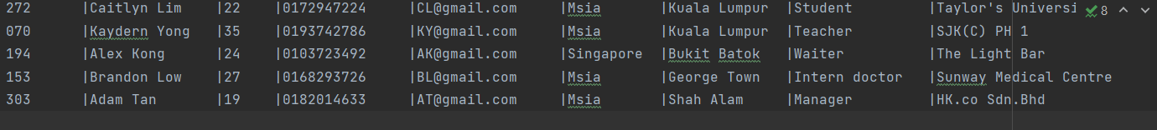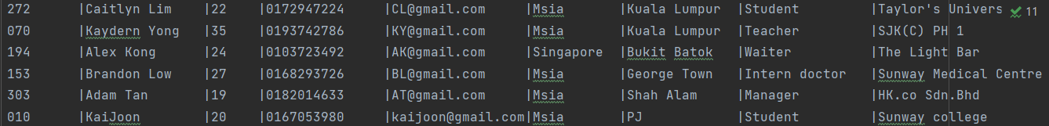Second **Update Record**, edit **/** update the details for tenant. Once tenant details updated, it will be modified into File.txt.

Third **Delete Record**. Once the record has deleted, it will be no longer show up in the File.txt.

Fourth **Find Special Room Number**, randomly enter a room number to look forward into record

### 4.6 Payment

**

If proceed **(2)** moving on to the **Payment** menu. Select **(1)** ‘Yes’ to next, **(2)** ‘No’ back to Menu.

If select **(1)** ‘Yes’, users may select their Online Banking Method to proceed.

**(USING MAYBANK AS AN EXAMPLE)**

If it’s **Maybank** user, first enter your full name per IC and account no. If account no is ‘too long’ or ‘not match’, it will be showing ‘PLEASE TRY IT AGAIN’ until it verified.

Once account verified.

Select **(1)** exit back to the Main Page ; Select **(2)** return to payment details which is ‘Online Banking Method’.

Select (4) **Cancel Payment** in Online Banking Method is to exit back to the Main Page

# **Conclusion**

In conclusion, in the journey of designing this program, we both understand that designing a program aren’t easy. Although we faced a lot of bugs and problems that we have to crack our head to fix, but the result is quite satisfying to us. This program can use to solve the problem that David and John face. They can now handle the rental business with a easier and clearer method. They can check the details of current tenant, past tenant and apartment condition with a click of a button, and also can edit the list with a few fingertips. This program can make their lives easier as it simplifies a lot of stuff for them. As this is one of the goals of programming which is to simplify repeating or complicated stuff so that users can do stuff easier. I believe that this program can help David and John solve their problem well.

# **Appendix**

|  |  |  |
| --- | --- | --- |
| **No.** | **Contribution toward group work** | **Names & Signatures** |
| 1 | Introduction and Assumptions | Yau Kai Joon |
| 2 | Design of the program – Pseudocode & Flowcharts | Split half & work together |
| 3 | Programming Concepts with source code for Explanation | Lim Yee Ern |
| 4 | Screenshots of sample input/output and explanation | Yau Kai Joon |
| 5 | Conclusion | Lim Yee Ern |